IP Course Work

Shuowen Wei

1. (a).

n=[6,10,14,16];

for i=1:4

H=hilb(n(i));

x=ones(n(i),1);

b=sum(H)';

str1=sprintf('******************Below are results when n = %d ', n(i));

disp(str1);

xinv=inv(H)*b; % here changes

r=b-H*xinv

ans=norm(r)/norm(b);

str2=sprintf('||r||/||b|| = %d ', ans);

disp(str2);

ans2=norm(x-xinv)/norm(x);

str3=sprintf('||x-xc||/||x|| = %d ', ans2);

disp(str3);

end

******************Below are results when n = 6

r =

1.0e-011 *

-0.168265401612189

0.151478829479856

0.241873188144837

0.274380518305861

0.284183787613301

0.283584267180004

||r||/||b|| = 1.679682e-012

||x-xc||/||x|| = 2.740675e-010

******************Below are results when n = 10

r =

1.0e-003 *

0.105144957538439

0.101883822839266

0.093818217963504

0.085898362362835

0.078850642165618

0.072713480089748

0.067382861255627

0.062736108250028

0.058662465744375

0.055068944807224

||r||/||b|| = 5.374333e-005

||x-xc||/||x|| = 2.949614e-004

******************Below are results when n = 14

{Warning: Matrix is close to singular or badly scaled.

Results may be inaccurate. RCOND = 2.448199e-019.}

r =

11.211912574059081

9.643824253303652

8.578298169798559

7.777496334628117

7.138748054779454

6.610363056712501

6.162489157997219

5.776135556189187

5.438364002908315

5.139908707056815

4.873880611178700

4.635007228245880

4.419159393609066

4.223042236819609

||r||/||b|| = 4.513560e+000

||x-xc||/||x|| = 1.953405e+001

******************Below are results when n = 16

{Warning: Matrix is close to singular or badly scaled.

Results may be inaccurate. RCOND = 9.721674e-019.}

r =

0.397759396971457

0.428331276653672

0.393492746335850

0.357423669324823

0.326067726361362

0.299431141370129

0.276742816124820

0.257252920804415

0.240351857889448

0.225562862271497

0.212514738918966

0.200916647517570

0.190538434185226

0.181195982804337

0.172740419585506

0.165050136480576

||r||/||b|| = 1.853781e-001

||x-xc||/||x|| = 4.407254e+000

diary off

(b).

for i=1:4

H=hilb(n(i));

x=ones(n(i),1);

b=sum(H)';

str1=sprintf('******************Below are results when n = %d ', n(i));

disp(str1);

xslash=H\b;; % here changes

r=b-H*xslash

ans=norm(r)/norm(b);

str2=sprintf('||r||/||b|| = %d ', ans);

disp(str2);

ans2=norm(x-xslash)/norm(x);

str3=sprintf('||x-xc||/||x|| = %d ', ans2);

disp(str3);

end

******************Below are results when n = 6

r =

1.0e-015 *

0

0.222044604925031

0

-0.111022302462516

-0.111022302462516

0.111022302462516

||r||/||b|| = 8.385055e-017

||x-xc||/||x|| = 1.593452e-010

******************Below are results when n = 10

r =

1.0e-015 *

0

0

0

0.222044604925031

0

0

0.111022302462516

-0.111022302462516

-0.111022302462516

-0.222044604925031

||r||/||b|| = 7.818087e-017

||x-xc||/||x|| = 4.697804e-004

******************Below are results when n = 14

{Warning: Matrix is close to singular or badly scaled.

Results may be inaccurate. RCOND = 2.448199e-019.}

r =

1.0e-014 *

0

-0.044408920985006

0

-0.088817841970013

-0.111022302462516

-0.088817841970013

-0.066613381477509

-0.111022302462516

-0.022204460492503

-0.044408920985006

0

-0.044408920985006

-0.044408920985006

-0.022204460492503

||r||/||b|| = 4.080976e-016

||x-xc||/||x|| = 2.256253e+001

******************Below are results when n = 16

{Warning: Matrix is close to singular or badly scaled.

Results may be inaccurate. RCOND = 9.721674e-019.}

r =

1.0e-015 *

0

-0.444089209850063

-0.222044604925031

-0.444089209850063

0.222044604925031

0

0.222044604925031

-0.444089209850063

0

0

0

0.111022302462516

0

0

-0.111022302462516

-0.111022302462516

||r||/||b|| = 1.441971e-016

||x-xc||/||x|| = 3.153211e+000

diary off

(c).

for i=1:4

H=hilb(n(i));

x=ones(n(i),1);

b=sum(H)';

str1=sprintf('******************Below are results when n = %d ', n(i));

disp(str1);

[U S V]=svd(H); % here changes

xcvd=V*inv(S)*U'*b;

r=b-H*xcvd

ans=norm(r)/norm(b);

str2=sprintf('||r||/||b|| = %d ', ans);

disp(str2);

ans2=norm(x-xcvd)/norm(x);

str3=sprintf('||x-xc||/||x|| = %d ', ans2);

disp(str3);

end

******************Below are results when n = 6

r =

1.0e-010 *

-0.488551421540251

-0.396724875173504

-0.336319860849699

-0.292602608809034

-0.259213761566457

-0.232780461573157

||r||/||b|| = 2.415780e-011

||x-xc||/||x|| = 2.446578e-010

******************Below are results when n = 10

r =

1.0e-004 *

0.522000112725962

0.442024673641406

0.382447837343758

0.336542476908619

0.300182689330075

0.270724376700837

0.246404376615939

0.226005901092785

0.208664123099167

0.193748575409991

||r||/||b|| = 2.210257e-005

||x-xc||/||x|| = 6.101151e-004

******************Below are results when n = 14

{Warning: Matrix is close to singular or badly scaled.

Results may be inaccurate. RCOND = 2.129129e-018.}

r =

-1.494122719216894

-1.373246261199923

-1.271238874632215

-1.183796832945275

-1.107894911689181

-1.041324072591237

-0.982423268726405

-0.929913969545744

-0.882793027187822

-0.840260596785741

-0.801670098297502

-0.766492564398156

-0.734290674080093

-0.704699480765274

||r||/||b|| = 6.824494e-001

||x-xc||/||x|| = 4.818414e+000

******************Below are results when n = 16

{Warning: Matrix is close to singular or badly scaled.

Results may be inaccurate. RCOND = 1.359388e-018.}

r =

2.170435585435376

2.024872088009600

1.897510784923737

1.785226867222649

1.685521080113281

1.596399623362868

1.516262422588390

1.443814164649639

1.377996442109772

1.317936506192885

1.262908472233979

1.212303740273705

1.165608237795715

1.122384743699171

1.082259028874951

1.044908890256198

||r||/||b|| = 9.947277e-001

||x-xc||/||x|| = 1.322478e+001

diary off

**The 2 condition number for each H:**

for i=1:4

H=hilb(n(i));

cond(H)

end

ans =

1.495105864100543e+007

ans =

1.602466539329798e+013

ans =

4.696757028504799e+017

ans =

7.356249230615104e+017

diary off

**Analysis：**

After check doc slash in Matlab, we find that X=H\b in Matlab use the QR decomposition with pivoting to compute. Actually, every matrix, even including deficient matrix, has QR decomposition where Q is unitary. It’s a better way and more accuracy than SVD ( svd(A) ) or by computing the inverse of H directly ( inv(H) ).

After examining and analysis the data of r, ||r||/||b|| and ||x-xc||/||x||, we found the value of r and the relative error between x and xc becomes larger when n is bigger, that’s because when n is bigger, the condition number of H is bigger, in another way of saying, H is more likely deficient and the problem is more ill-conditioned.

2.

**plot:** this is linear plot. PLOT(X,Y) plots vector Y versus vector X.

**axes:** this is for creating axes in arbitrary positions. AXES('position', RECT) opens up an axis at the specified location and returns a handle to it.

**axis:** control axis scaling and appearance. AXIS([XMIN XMAX YMIN YMAX]) sets scaling for the x- and y-axes on the current plot.

**hold:** Hold current graph HOLD ON holds the current plot and all axis properties so that subsequent graphing commands add to the existing graph.

**legend:** LEGEND Display legend. LEGEND(string1,string2,string3, ...) puts a legend on the current plot using the specified strings as labels.

**line:** Create line. LINE(X,Y) adds the line in vectors X and Y to the current axes.

**LineWidth:** The width of linear objects and edges of filled areas. Specify this value in points (1 point = 1/72 inch). The default LineWidth is 0.5 points.

**loglog:** LOGLOG(...) is the same as PLOT(...), except logarithmic scales are used for both the X- and Y- axes.

**plot3:** The plot3 function displays a three-dimensional plot of a set of data points

**plotyy:** PLOTYY Graphs with y tick labels on the left and right PLOTYY(X1,Y1,X2,Y2) plots Y1 versus X1 with y-axis labeling on the left and plots Y2 versus X2 with y-axis labeling on the right.

**semilogx:** SEMILOGX(...) is the same as PLOT(...), except a logarithmic (base 10) scale is used for the X-axis.

**semilogy:** SEMILOGY(...) is the same as PLOT(...), except a logarithmic (base 10) scale is used for the Y-axis.

**subplot:** SUBPLOT Create axes in tiled positions. H = SUBPLOT(m,n,p), or SUBPLOT(mnp), breaks the Figure window into an m-by-n matrix of small axes, selects the p-th axes for the current plot, and returns the axes handle.

**title:** Graph title. TITLE('text') adds text at the top of the current axis.

**xlabel:** X-axis label. XLABEL('text') adds text beside the X-axis on the current axis.

**xlim:** X limits. XL = XLIM gets the x limits of the current axes. XLIM([XMIN XMAX]) sets the x limits.

**ylabel:** Y-axis label. YLABEL('text') adds text beside the Y-axis on the current axis.

**ylim:** YLIM Y limits. YL = YLIM gets the y limits of the current axes. YLIM([YMIN YMAX]) sets the y limits.

**Illustrate:**

clc;clear

x=0:0.01:2*pi;

y=sin(x);

z=cos(x);

plot(x,y,'-bo');

hold on

plot(x,z,'-ro');

axis([0 2*pi -1.5 1.5])

title('y=sin(x) and z=cos(x)');

legend('y=sin(x)','z=cos(x)');

xlabel('value of x');

ylabel('value of y and z');

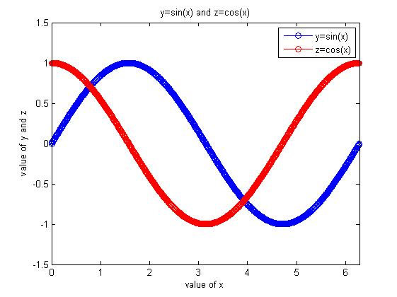

clear;clc

x=0:0.01:10;

y=10.^x;

z=exp(x);

a=200*exp(-x);

b=20*exp(-x);

subplot(2,2,1)

semilogy(x,y,'ro')

subplot(2,2,2)

semilogx(y,x,'b*')

subplot(2,2,3)

loglog(x,z,'-gO')

subplot(2,2,4)

plotyy(x,a,x,b)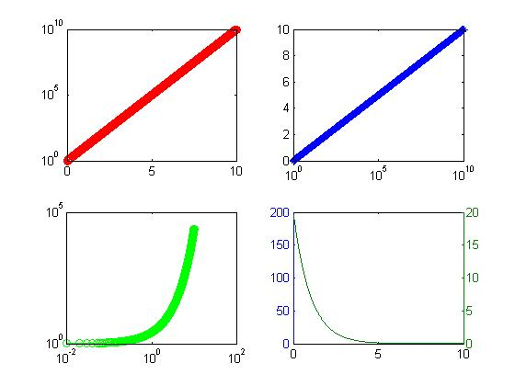

clc;clear

t = 0:pi/50:10*pi;

plot3(sin(t),cos(t),t)

grid on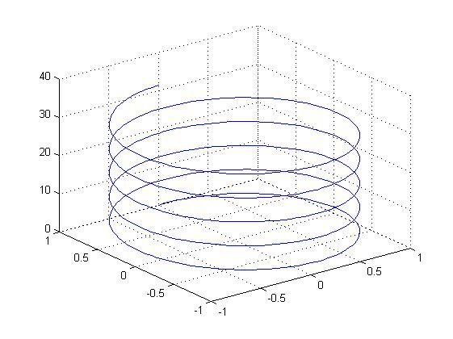

x=0:0.1:2;

y=sin(x);

plot(x,y,'*')

hold on

line(x,y)

